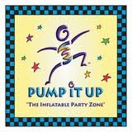

It’s official! Our first PTO meeting of the year will be at Pump It Up!!!!!

While the kids bounce away*, the adults will get down to business.  
We will give a general overview of the PTO events we have planned, take suggestions and comments, and select and finalize our Committee Chairs for this academic year.

**Where:** Pump It Up **Date:** Thursday, October 6, 2016

8 Commerce Way, Suite 135 **Time:** Doors open at 6:00 PM

Hamilton, NJ 08691 Meeting begins at 6:30 / 8:00 PM close

(609) 586-5577 **Cost:** only $5.00 per child

**\*\* Please note children must be at least 34” tall for all inflatables.**Socks are required.**

Student’s Name: ________________________ Teacher:__________________

____ # of children attending ($5.00 per child) Total enclosed:_____________